Corn Bioethanol Production

Ei Ei Chaw, Michael Liu, Kian Moslehi, Sandeep Singh, Harry Zhao

SJSU

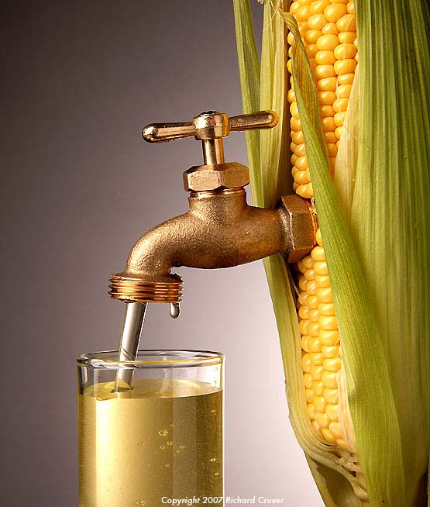

Table Of Content

1. Abstract………………………………………………………………...……...2

2. Conceptual System Design……………………………………………...…….3

3. Preliminary System Design……………………………………………...……6

3.1 Black Box System Design…………………………………….....6

3.2 Overall System Approach…………………………………….....8

3.3 Key Production Variables…………………………………….....9

4. Detailed Design and Development…………………………………………...10

4.1 Wet Milling Vs. Dry Milling……………………………………11

4.2 Modified Dry Milling…………………………………………...12

4.3 Technical Performance Measures……………………………….14

4.4 Trade-Off Analysis……………………………………………...14

5. Economic Evaluations ……………………………………………………… 16

6. Summary……………………………………………………………………. 22

7. References…………………………………………………………………… 24

8. Appendix……………………………………………………………………...26

**Abstract**

One of the biggest issues of our generation is climate change. Climate change has been brought about by over a century of unrestrained fossil fuel burning starting from the Industrial Revolution and has continued to the present day. In the past few decades, there has been a growing effort to develop certain technologies that lower or mitigate the environmental impact of generating power. One segment of the “green” technology sector that has seen a lot of investment has been biofuels. Biofuels range from solid fuels (e.g. charcoal) to liquid fuel (e.g. ethanol). There are many different biofuel sources and they vary depending on what type of biofuel feedstock is available in a whatever region the biofuel will be made. For our project, we chose to work on corn-based bioethanol production since corn is already the most prevalent feedstock used to make bioethanol in the United States. Our primary focus is to drive down the price of ethanol so that it is competitively priced against gasoline. Our secondary goal is to create a carbon cycle that helps sequester some of the carbon dioxide that is in the air. In this report, we shall discuss the initial stages of formulating our system, the iterative process of improving our design, our methodology, why we made certain design choices, and how we chose our final system design.

**Conceptual System Design**

In 2005 our increasing reliance on fossil fuels has led congress to establish the Renewable Fuel Standard. This program is responsible for expanding the nation’s renewable fuel sector while reducing reliance on imported oil. The production of corn-based bioethanol uses existing agricultural infrastructure to produce a renewable fuel source which can be incorporated to power our transportation needs. Our main objective is to increase the yield of corn-based ethanol production through analysis/optimization of components of the production life cycle.

To begin our analysis, we identified three major subsystems for our corn biofuel system. The agricultural system is responsible for fuel stock yields, the fuel plant production system is responsible for bio ethanol yields, and the government system is responsible for economic factors supply, demand, and subsidization. Although these three systems all influence biofuel production, we are interested in the optimization of the fuel production system.

Our system will require a milling plant to be built. The milling plant will process the corn kernels into a biomass that can be efficiently converted into ethanol. This plant will need to be staffed by specialized personnel, engineers (maintenance, quality assurance, systems), operators, and technicians. Infrastructure required are milling machines, storage tanks, distillation equipment, and an energy heating/cooling system required for our specific bioethanol process.

In order to better understand how we could improve the yield of the ethanol production process, we begin our analysis on the bioethanol production process. There are several technical performance measures (TPM) which we use to describe a product. The critical TPM’s for our objective are Operating Cost, Maintenance Cost, Fuel Cost (cost/gallon), process steps, MTBM (mean time between maintenance), and Production Yield (gal/bushel).

Ideal production conditions will require a warm growing period of 60-100 days for maximum crop yields, which will increase output of our ethanol production system. During times of excess heat, periodic drip irrigation can be applied infrequently to keep the ground cool. To prevent the unhealthy characteristics of monocrops, crop rotation will be used to ensure that the nutrients in the soil are maintained. Our production operation relies on government subsidies and fuel mandates. Therefore establishing and maintaining clear lines of communication with federal agencies will be needed to maximize our system outputs.

Our main focus is increasing the efficiency of the ethanol production system. To maximize the lifespan of our factory operation, we will instill a rigid set of factory regulations. These will be implemented through preventative, predictive, and corrective maintenance routines.

To measure the efficiency of our bioethanol plant’s performance, we will be focusing on the milling process that grind the corn kernel into milled corn. Production requirements are based on national averages for bioethanol plants and are listed as follows.

|  |  |
| --- | --- |
| Operational Cost ($) | 44,644,500 |
| Maintenance Cost ($) | 750,000 |
| Cost per Gallon ($) | 1.03 |
| Number of Production Process steps | 16 |
| MTBM (hr) | 2688 |
| Yield (gal/bushel) | 2.8 |

After completing Quality Deployment Function (see attached file), customer and stakeholder needs were thoroughly assessed and ranked as shown in (**Customer Importance, Table 1 Appendix A)**.

**Preliminary System Design**

Having agreed upon and made a conceptual system design, the group then commenced working on the preliminary system design. Our primary objective was to make a rough plan of how our system would work. This would then provide the framework for us to fill in the gaps and provide technical details later on during the detail design and development (DDD) phase. We did this by defining the functions we needed as a black box so that we could later decided on how to carry out the different functions during the DDD phase. We also began considering what the best approach was to making ethanol on a large scale. Lastly, since our overarching system objective is to improve upon the yield of corn-based ethanol production, we had to quickly ascertain which variables would increase the yield of ethanol production.

**Black Box System Design**

We commenced this portion of the preliminary design phase by mapping out the various subsystems our system needed in order to convert corn into ethanol. The primary functions that our system needs to put into consideration include the following:

1. Raw material (biomass) gathering
2. Storage of raw material
3. Processing of biomass into biofuel
4. Storage of biofuel
5. Waste disposal management

We also had some secondary functions that, while we did not fully explore due to the scope and the time of the project, we thought were important to touch upon during this phase. The secondary functions are as follows:

1. R&D (for improving system efficiency, improving yield, lowering costs, etc.)
2. Safety protocols
3. Resource availability during off-season

Once we determined the primary functions, we then visually mapped out the functions in a functional analysis diagram. This diagram shows the key steps and functions that will be carried albeit the view of the system as portrayed below in Figure 1 is at a very high level and, hence, not very detailed. Our preliminary design states that first corn farms will produce the corn our ethanol production system needs. Next, farmers will harvest the corn. We will then arrange for the corn to be transported to our ethanol production plant. The corn will be processed into ethanol. The ethanol will be extracted from the mixture of wastewater and solid waste. The wastewater will be recycled. The final function in the system is to distribute the ethanol.

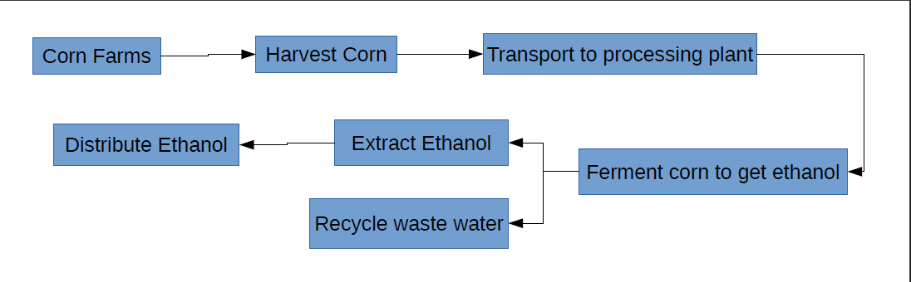

Figure 1. High-Level Functional Analysis Diagram

**Overall System Design Approach**

Having generated a basic outline of how our system would work, we looked at how to implement such a design. Three options were created: 1) a distillery design 2) an oil refinery design or 3) a hybrid between a distillery and an oil refinery. The main distinction between the options are the products that can be made, the quantity of product that can be made, and the size of the plant (i.e. the larger the plant, the more products that can be made).

The distillery design is exactly what it sounds like: creating a distillery to produce alcohol. Fortunately, there is a relatively low risk to investment that can be attributed to a number of factors. First, distilleries as an engineering system have been proven to work reliably and can be reliably constructed. That is to say that no special engineering needs to be performed that will drive up the cost of ethanol production. However, only three outputs are generated: 1) ethanol, 2) dried distillers grains with solubles (DDGS), and 3) CO2. Aside from ethanol, we can sell DDGS as feed for livestock and it is possible to collect the CO2 and sell it. However, most ethanol production facilities vent the CO2 into the atmosphere.

The oil refinery design’s big advantage is its production capacity and its ability to create a wide range of petroleum products. An existing oil refinery can be fitted to produce ethanol. However, oil refineries have a negative impact on the environment and integrating our system in an oil refinery would go against our objective since part of the reason why we would like to engineer an ethanol production system is due to our desire to reduce the environmental impacts of burning fossil fuels. Also, much more engineering must be performed in order to build a safe and reliable plant, which drives up the overall cost of implementing such a system.

The last design is the refinery-distillery hybrid design. This design is similar to the distillery design yet it is applied on the scale of a refinery. The outputs of this ethanol plant would still be ethanol, DDGS, and CO2 but they are produced at a much larger scale. The cost of building such a plant would be more expensive than a regular distillery, less expensive than building a refinery. The DDGS can be sold to farmers and the excess CO2 can be vented unless there are local emissions restrictions in which case the CO2 will most likely have to be sold.

Having explored these design options, we decided to go with a dual approach. We will initially use the distillery design for our bioethanol production system. However, we will build it on land that gives us the possibility to expand our facility in the future. If our system attains profitability, we will expand the facility to create the refinery-distillery hybrid so that we could have a higher yield of ethanol albeit only if it makes economic sense to do so (e.g. demand for ethanol becomes high, price of oil increases, etc.).

**Key Production Variables**

After having determined the overall system design approach, we then worked on identifying the variables we would have to change so as to improve the process efficiency of making ethanol. We did this by reading a number of research papers. By the end of this process, we ended up with two variables that had a direct influence on making ethanol. The three variables are as follows: 1) milled grain size and 2) using antibiotics.

Milled grain size has a direct relationship with ethanol yield since the smaller the grain size is, the more ethanol will be produced during fermentation. As the milled grain size decreases, the ethanol yield increases. The small surface-area-to-volume ratio of the smaller grains allow for the grain to cook easily and is that increasing the surface-area-to-volume ratio will allow for better fermentation.

Another variable that would improve the ethanol yield is the use of antibiotics during the fermentation process. During fermentation, the biomass is mixed with water, yeast, and is left to ferment. Left to its own devices, the mixture will ferment and produce ethanol. However, approximately 8.8% more ethanol can be produced by using antibiotics during the fermentation stage. Fermentation is a process by which yeast, which is a fungus, consumes sugar in the fermentation still and converts the sugar into ethanol. If the milled corn is placed into the fermentation still without antibiotics, the bacteria in the still and on the milled corn will compete with the yeast and make the fermentation process less efficient. Using antibiotics will kill the bacteria in the still, allowing for more efficient fermentation and for more ethanol to be produced.

With our preliminary system design in hand and the knowledge of what parameters we can change in order to improve ethanol yield in mind, we then proceeded to begin the DDD phase.

**Detailed Design and Development (DDD)**

During the DDD phase, we further refined what we had developed during the conceptual and the preliminary design phases. In order to do so, we had to learn about the most prevalent methods used to make ethanol. We researched and chose between the two methods the industry uses to make ethanol: wet milling and dry milling. We also finalized our list of TPMs. We then used certain TPMs that we deemed key indicators of system viability to use in our trade-off analysis.

**Wet Milling Vs. Dry Milling**

There are two main types of ethanol production processes: wet milling and dry milling. 18% of the total US ethanol production is from wet milling plants. Wet milling plants require 20 steps to be taken to complete one system cycle. In this process, clean corn is mixed into a vat in the lead up to the extraction process. During the extraction process, the corn kernel is broken down into starch, fiber, corn germ, and protein by heating the mixture in a sulfuric acid solution for 2 days. This mixture is then removed from the vat and transferred to a fermentation vessel. In the fermentation vessel, two types of enzymes, glucoamylase and α-amylase, are added to the mixture to convert the starch slurry to glucose or to convert into syrup. Then hydrochloric acid, enzymes, and yeast are added to ferment the starch slurry. The slurry is then distilled to get ethanol. Additional byproducts include corn oil, gluten meal, and gluten feeds, which can be sold to make other products.

Dry milling is actually a subprocess of wet milling. Dry milling as a separate process takes 16 steps to complete a system cycle. The main difference between the dry milling process and the wet milling process is that in dry milling rollers are used to grind corn kernels and only enzymes are used during the fermentation process. However, dry milling is preferred in the industry over wet milling. This is due to multiple reasons: 1) less equipment is needed since only ethanol, DDGS, and CO2 are being produced (i.e. no other corn byproducts are being made), 2) operating costs go down since there are fewer pieces of equipment involved in the manufacturing process, 3) maintenance costs are lower since there are fewer pieces of equipment, 4) the space requirements, and thus the necessary amount of land required to purchase or lease, are also less. Dry milling clearly has an economic advantage over wet milling for the purposes of our system. We will be using dry milling for our system but it will be a modified dry milling process (**Documentation Tree, Figure 2 Appendix B**).

The dry milling follows the following process: the mill grinds the corn to the desired size. Next, during liquefaction, water and stillage (i.e. recycled water from the plant) are added to the milled corn to create a corn mash. This process hydrolyzes the starch. During this process, the pH level must be maintained between 5.9 and 6.2. In order to do this, ammonia and sulfuric acid are added. In the sterilization step, enzymes like amylase are added to the corn mash prior to jet cooking the mixture for 2 to 7 minutes at 105 C to 120 C. Cooking the mash helps avoid bacterial contamination during fermentation and also improves upon the viscosity of the mix. The mixture is then cooled down. Next, during saccharification, the enzymes glucoamylase and amylase are added to the cooled down mash to extract convert starch into sugar for fermentation. Then, during fermentation, a yeast called saccharomyces cerevisiae is added to the mash. The mixture is fermented for 2 to 3 days in fermentation tanks at a temperature between 30 and 32 C.

**Modified Dry Milling**

Our system will use a modified dry milling process to make ethanol. We already referred to the changes we would make in the preliminary design section. The changes we mentioned in that section include using antibiotics, and using hammer milling to mill the corn kernels to a uniform grain size of 3 mm. We also included additional parameters that we learned of while researching papers and articles during the DDD phase that can increase the yield of ethanol. We will discuss these parameters next.

Since our objective is to increase the yield of ethanol by modifying parameters in our production system, we would like to draw attention on the key stages of our modified dry milling process. In addition to the two parameters we discovered will increase ethanol yield (milled grain size and using antibiotics during fermentation), we found three other parameters that will increase the ethanol yield. We added these five parameters to the original dry milling process in order to make our modified dry milling process. These changes aim to increase the ethanol production yield of the dry milling process while maintaining the cost savings from using dry milling as opposed to wet milling.

Of the three new parameters, we first start with hammer milling. We propose using hammer milling instead of rollers (**Specifications, Appendix B Figure 1)**, which are used in the traditional dry milling process, to grind the corn kernels. By using hammer milling, we can control the grain size of the milled corn. We can do this since the machine will continue to grind the larger particles until they are small enough to pass through the screen of the unit, the holes of which are at the desired diameter. By getting the milled corn to be one consistent size, we can ensure better fermentation.

Second, we use enzymes called amylase during the liquefaction process. Using amylase increases the yield by 8.8% compared to using other kinds of enzymes. Amylase breaks down the starch in the milled corn into sugar. The sugar is then consumed by the yeast, which produces the ethanol.

Finally, The last variable that we will change is to combine two processes in order to carry out Simultaneous Saccharification and Fermentation (SSF). SSF involves combining the processes of saccharification and fermentation into one step. SSF lowers initial glucose concentrations, lowers contamination risk, lowers energy requirements, and produces higher yields of ethanol. In this process, glucoamylase and yeast are added together to the water and corn mash mixture. This step is done under temperature 32 to 35 C.

We finalized our system design by creating a documentation tree and a functional analysis diagram (**Appendix B, Figure 2 and Figure 3, respectively**). With our system designed, we proceed to take a final tally of our TPMs. (**Stakeholder TPM Relationship, Table 2 Appendix A)**

**Technical Performance Measures**

With our system design complete, we took stock of all of our TPMs and who the various stakeholders are. For each TPM, we made a note of whether or not each TPM was of importance for each group of shareholders, as can be seen in Table 2 in the appendix.

**Trade-Off Analysis**

From the TPMs that we listed in Table 2 in the Appendix, we chose six TPMs that we felt were the best indicators of system viability. The six TPMs are as follows: operational cost, maintenance cost, cost per gallon of ethanol, number of process steps, mean time between maintenance (MTBM), and yield. We compared wet milling, traditional dry milling, and our modified dry milling processes using these six TPMs. The breakdown and decision making can be seen in Figure 3 and Figure 4.

In our trade-off analysis, we compared wet milling, dry milling, and our modified dry milling to an “ideal” system. We chose values for the ideal system based upon what we thought the TPM values for an ideal system could be after having learned about wet milling and dry milling. We used Figure 3 to help us visually compare the different milling processes. The “x”s in Figure 4 indicate that the capabilities of that process do not meet the ideal standard. The tildes signify that a requirement is almost met.

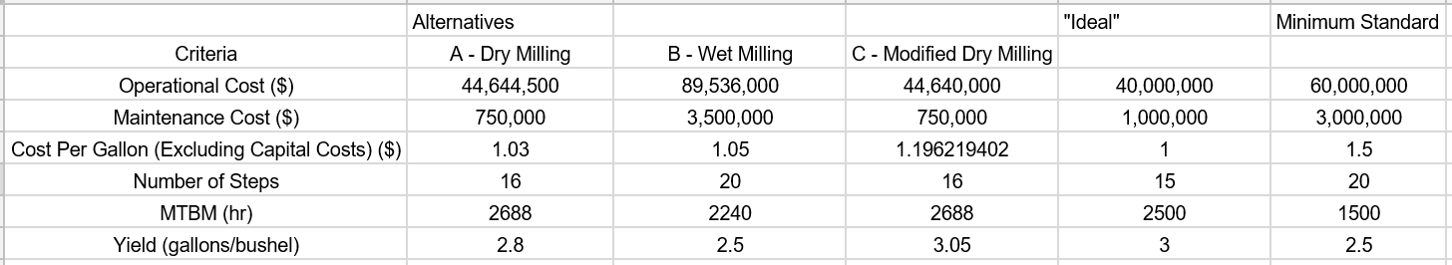

Figure 3 - Quantitative Trade-off Analysis

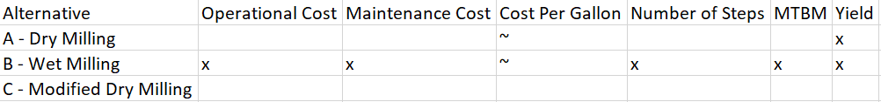

Figure 4 - Simplified Trade-Off Analysis

As can be seen from Figure 3 and Figure 4, our modified dry milling process meets all of the requirements. Our ideal system had an operation cost of $40 million, a maintenance cost of $750,000, $1 per gallon of ethanol, 15 steps, 2500 hrs for MTBM, and a yield of 3 gallon per bushel. We based our values for modified dry milling on the values for traditional dry milling. The operational costs for modified dry milling will be less since we are combining processes by carrying our SSF. We found the cost per gallon of ethanol by finding the average ratio of the yield and cost per gallon of ethanol for both wet milling and traditional dry milling. We used then divided the yield of modified dry milling by the averaged ratio to find a very conservative estimate for the cost per gallon of ethanol by using our system. Our estimated per gallon cost for ethanol using our approach is approximately $1.20. However, we anticipate the cost to be actually closer to one due to the improvements that we made in yield. We also were able to estimate the yield of modified dry milling by taking into account the 8.8% increase in yield by using antibiotics. This 8.8% increase in yield corresponds to a yield of 3.05 gallons per bushel of corn for modified dry milling whereas traditional dry milling, which uses no antibiotics, has a yield of 2.8 gallons per bushel. For the benefit of investors and stakeholders, we assumed the maintenance costs, MTBM, and number of steps to be the same so as to provide a more conservative estimate since we are not aware of any ethanol production system that is similar to ours and, therefore, we have no real world data on how it performs.

As can be ascertained from Figure 4, our modified dry milling process is the closest to the ideal example that we created. We are confident that our system is the best system given the TPMs we used to make comparisons. We shall next perform the economic evaluation of our system.

**Economic Evaluation**

Due to the potential overwhelming and difficult-to-follow nature of presenting our economic evaluation in a purely written format, we chose to write our evaluation in a hybrid format. Parts of our evaluation are listed line by line in order to allow for easy reading. We also provide our own insights and analysis in between the line-by-line breakdown.

1. Costs involved
   1. Building site/Plant construction - **$8 million**
   2. Plant Machinery - **$10 million**
   3. Initial operating capital(10% of the total) - **$5 million**
   4. Corn - **$3/bushel \***
   5. Storage area for corn ( upto 10 day’s stock)- 600,000 bushels of corn.
   6. Storage area cost - $0.8 per bushel
   7. Operating Expenses-
      1. Natural gas costs (per btu) - **$9** per btu
      2. Natural gas requirements (in btu) - **34000**
      3. Electricity costs - **$ 0.08/Kw**
      4. Electricity requirements (Kw per bushel)- **0.75 Kwh/gallon**
      5. Transportation of Corn bushel - **$0.10** per bushel
   8. Chemicals expenses - **$7.14**
      1. Antibiotics+boiler +cooling tower chemicals - **$0.025 * 60 = $1.5 million**
      2. Enzymes- 0.0480 * 60 million = **$2.88 million**
      3. Yeast - 0.022 * 60 million = **$1.32 million**
      4. Water requirements (in gallons to produce per gallon of ethanol) - **$0.006** * **4 * 60 million = $1.44 million**
   9. Other processing costs- **$3.802 million**
      1. Labor costs(2% of total)- **$2.272 million**
      2. Real Estate tax - 0.020 per gallon * 60 = **$0.12 million**
      3. License fee and Insurance- $0.0040 per gallon * 60 = **$0.24 million**
      4. Maintenance and Repairs- $0.0125 per gallon * 60 = **$0.75 million**
      5. Management and Quality Control- $0.0070 * 60 = **$0.42 million**
2. Revenue generated from:
   1. Denatured Ethanol- 60 million @$1.52 = **$91.2 million**
   2. Dried Distillers Grains with Solubles (DDGS)- 18 pounds per bushel or 6.428 pounds per gallon. Sell at $0.332 per gallon or **$0.0620 per pound = $19.93 million**
   3. Carbon Dioxide (CO2)- 18 pounds per bushel $6/2000 pounds or **$0.0192 per gallon = $1.52 million**

**Total Revenue : 91.2 + 19.93 + 1.52 = $112.65 million**

The investment required to build a 50 million gallon plant (natural gas fired) is $112.5 million. Building a 100 million gallon plant costs $180 million. We have considered the interest rate to be 9%. To get a yield of 50 million gallons of ethanol, we need 21.05 million bushel of corns at $3 per bushel. The total costs of a plant producing 50 million gallons of ethanol per year (can assume 60 million above nameplate capacity) are as follows:

Fixed Costs -

1. Plant machinery setup costs - **$23 million**

Operating Costs -

1. Raw Corn : $3 * 21.05 million bushel = **$63.15 million**
2. Natural gas - $9/million btu * 34000 btu = $0.306/bushel * 60 million = **$18.36 million**
3. Electricity - 0.75Kw per gallon * 0.08 per Kw * 60 million gallon ethanol = **$3.6 million**
4. Transportation costs - $ 0.10 * 21.05 million bushel = **$2.105 million**
5. Labor cost - **$2.2 million**
6. Chemical costs - **$7.14 million**
7. Storage costs - 600,000 * $0.8*12 = **$5.76 million**
8. Other processing costs - **$3.802 million**

Total Operating Costs - $106.117 million per year

Total Fixed Costs (in 10 years in million) :

$23 Initial plant set-up cost

+ $5 overhaul at the end of 3rd year

+ $5 overhaul at the end of 6th year

Total Fixed Costs = **$33 million**

**First year**

Costs : $106.117

Additional costs(applicable to 1st year only) = $18 million

Revenue : $112.65 million

Profit : $112.65 - 106.117 = **$6.553 million**

**Second year**

Costs : $106.117 million

Revenue : $112.65 million

Profit : $112.65 - 106.117 = **$6.533 million**

**Salvage value** at the end of 15th year **- $7 million**

|  |  |  |
| --- | --- | --- |
| Item | Disbursements (in million $) | Savings (in million $) |
| Plant building costs | 23 | -- |
| Saving 1st year | -- | 6.533 |
| Saving 2nd year | -- | 6.533 |
| Saving 3rd year | -- | 6.533 |
| Plant wear tear + disposal (3rd year) | 5 | -- |
| Saving 4th year | -- | 6.533 |
| Saving 5th year | -- | 6.533 |
| Saving 6th year | -- | 6.533 |
| Plant machinery costs(6th year) | 5 | -- |
| Saving 7th year | -- | 6.533 |
| Saving 8th year | -- | 6.533 |
| Saving 9th year | -- | 6.533 |
| Saving 10th year | -- | 6.533 |
| Salvage costs 10th year | -- | 7 |

1. **Present Equivalent Evaluation(PE )**

PE(9) = -23(1.09)0 +6.533(1.09)-1 + 6.533(1.09)-2 + 1.533(1.09)-3 + 6.533(1.09)-4 + 1.533(1.09)-5 + 1.533(1.09)-6 + 6.533(1.09)-7 + 6.533(1.09)-8 +6.533(1.09)-9 + 13.533(1.09)-10

PE(9) = -23 + 5.99+ 5.49 + 1.18 + 4.63 + 4.26 + 0.92 + 3.574 + 3.28 + 3.00 + 5.72

= **$15.044 million**

1. **Annual Equivalent Evaluation(AE)**

AE(i) =

AE(9) = $15.044

= **$2.33 million**

The initial investment of **$23 million** is made in setting up the plant. 9% return will be received plus additional **$2.33 million** each year for next **10 years**.

1. **Future Equivalent Evaluation (FE)**

or *PE(i) \**

= **$35.62 million**

Since future equivalent amount is much greater than 0. This is desirable venture at 9%.

1. **Rate of Return (ROR)**

At i = 20:

=

27.38 + 1.13 = 23 + 2.89 + 1.67

28.52 ≠ 27.57

At i = 25:

=

23.32 + 0.75 = 23 + 2.56 + 1.31

24.08 ≠ 26.87

Interpolating,

= 20 + 5 * 0.254

= **21.27 %**

The rate of return on the venture is **21.27%** which means that the investment of **$23 million** in the corn bioethanol plant should yield a 21.27% rate of return over 10-year period.

1. **Payout Evaluation**

Using present equivalent approach

The smallest value of *n\** that satisfies the above expression is the payout duration.

At i = 9% and t = 4:

=

At i = 9% and t = 6:

=

Interpolating gives,

n= 4 + 0.17

n = **4.17 years**

Therefore the payout period on the corn bioethanol plant is 4.17 years.

**Summary**

As fossil fuel reserves begin to diminish and the threat of climate change becomes much more evident, the demand for bioethanol as an alternative energy source continues to grow. Corn-based ethanol fuel is not the only renewable fuel source. As the various ethanol production technologies mature, we will be able to use a much wider variety of fuel stock types. Because of the complexity in understanding the biochemistry of bioethanol fuel, we took a much higher level approach for our paper. Instead of increasing the efficiency of the actual fuel, we applied our system of a systems approach to analyze the corn bioethanol fuel system, which enabled us to streamline the production process and to change various process parameters to in order to increase the ethanol yield.

After much research into the milling production processes, we created our own milling process by modifying the existing dry milling process. Our modified dry milling system was able to meet the benchmark values for all of our TPM’s. We see a reduction in both operational costs as well as increases in yield. Our economic analysis has evaluated that our system can be financially successful and can provide a high rates of return over a 10 year period. Since our production system is a modification of an existing production process, it can be quickly implemented. This is because very few changes need to be made to a traditional dry milling system in order to get the economic, cost, and production benefits our system provides. Although corn seems like a viable fuel alternative, some of the foreseeable obstacles ahead that require fixes are: 1) corrosivity of corn ethanol results in inadequate logistics infrastructure. Even if we maximize our output from each factory, the ethanol cannot get distributed quickly enough for it to be utilized effectively. 2) Corn ethanol is restricted to specific growth climates. There are many different fuel crops all with their own positives and negatives. As research in biofuels continues to advance, corn’s effectiveness as a biofuel may turn out to be lower when compared to some new fuel crop, which could potentially render our modified dry milling process obsolete. Our team’s system engineering approach allowed us to optimize our process component by component. This process has culminated in an environmental-friendly, economically-sustainable, and technologically-viable milling process that can easily be incorporated into existing ethanol production systems.

**References**

* Clifford Caroline Burgess (2018). How corn is processed to make Ethanol. Faults | Earth 520: Plate Tectonics and People: Foundations of Solid Earth Science.
* Zhao Y, Damgaard, Thomas H, Christensen (2018) duplicated. Bioethanol from corn stover - a review and technical assessment of alternative biotechnologies . Progress in Energy and Combustion science.
* Conca James.(Published - 2014) (edited 2018) It’s final -- corn ethanol is of no use. Forbes Magazine.
* Coradi, Paulo Carteri and Milane, L.V. and Camilo, L.J. and Andrade, M.G.O (2016) duplicated. Drying and storage of corn grains for ethanol production in brazil. Bioscience Journal.
* Austin Anna. (published- 2009)(edited- 2018). Storage Strategies for cellulosic feedstocks @ Ethanol Magazine. Ethanol Producer Magazine- The Latest News and Data About Ethanol Production.
* Alibaba. (2018). Corn Hammer Mill. Alibaba.
* AMG Incorporated (2018). Corn Milling: Wet vs. Dry Milling. AMG Engineering Blog.
* Clifford, C. (2018). 7.3.2 How Corn is Processed to Make Ethanol | EGEE 439:. Retrieved from <https://www.e-education.psu.edu/egee439/node/673>
* Dry Grind Production of Ethanol. (2018). Retrieved from https://grains.org/wp-content/uploads/2018/06/Chapter-3.pdf
* Corn wet-milling. (2018). Retrieved from <https://en.wikipedia.org/wiki/Corn_wet-milling>
* *ASHRAE Equipment Life Expectancy Chart*. ASHRAE, [www.culluminc.com/images/ASHRAE_Chart_HVAC_Life_Expectancy%201.pdf](http://www.culluminc.com/images/ASHRAE_Chart_HVAC_Life_Expectancy%201.pdf).
* Havran, N. (2018). Ethanol Producer Magazine – The Latest News and Data About Ethanol Production. Retrieved from http://www.ethanolproducer.com/articles/1886/maintenance-as-a-profit-center-in-a-fuel-ethanol-plant#
* <https://en.wikipedia.org/wiki/Corn_wet-milling>
* Chaplin Martin. (2014). The use of enzymes in starch hydrolysis. Enzymes Technology.

**Appendix A: Tables**

|  |  |  |
| --- | --- | --- |
| Technical Performance Measure | Average Benchmark | Customer Importance |
| Operational Cost ($) | 44,644,500 | 20% |
| Maintenance Cost ($) | 750,000 | 10% |
| Cost per Gallon ($) | 1.03 | 20% |
| Number of Process Steps | 16 | 10% |
| MBTM(hrs) | 2688 | 10% |
| Yield (gal/bushel) | 2.8 | 30% |

**Table 1 : Customer Importance**

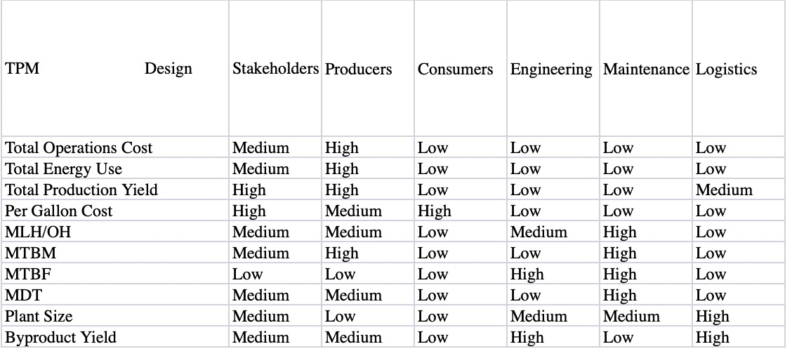

**Table 2: Stakeholder TPM Relationship**

**Appendix B: Figures**

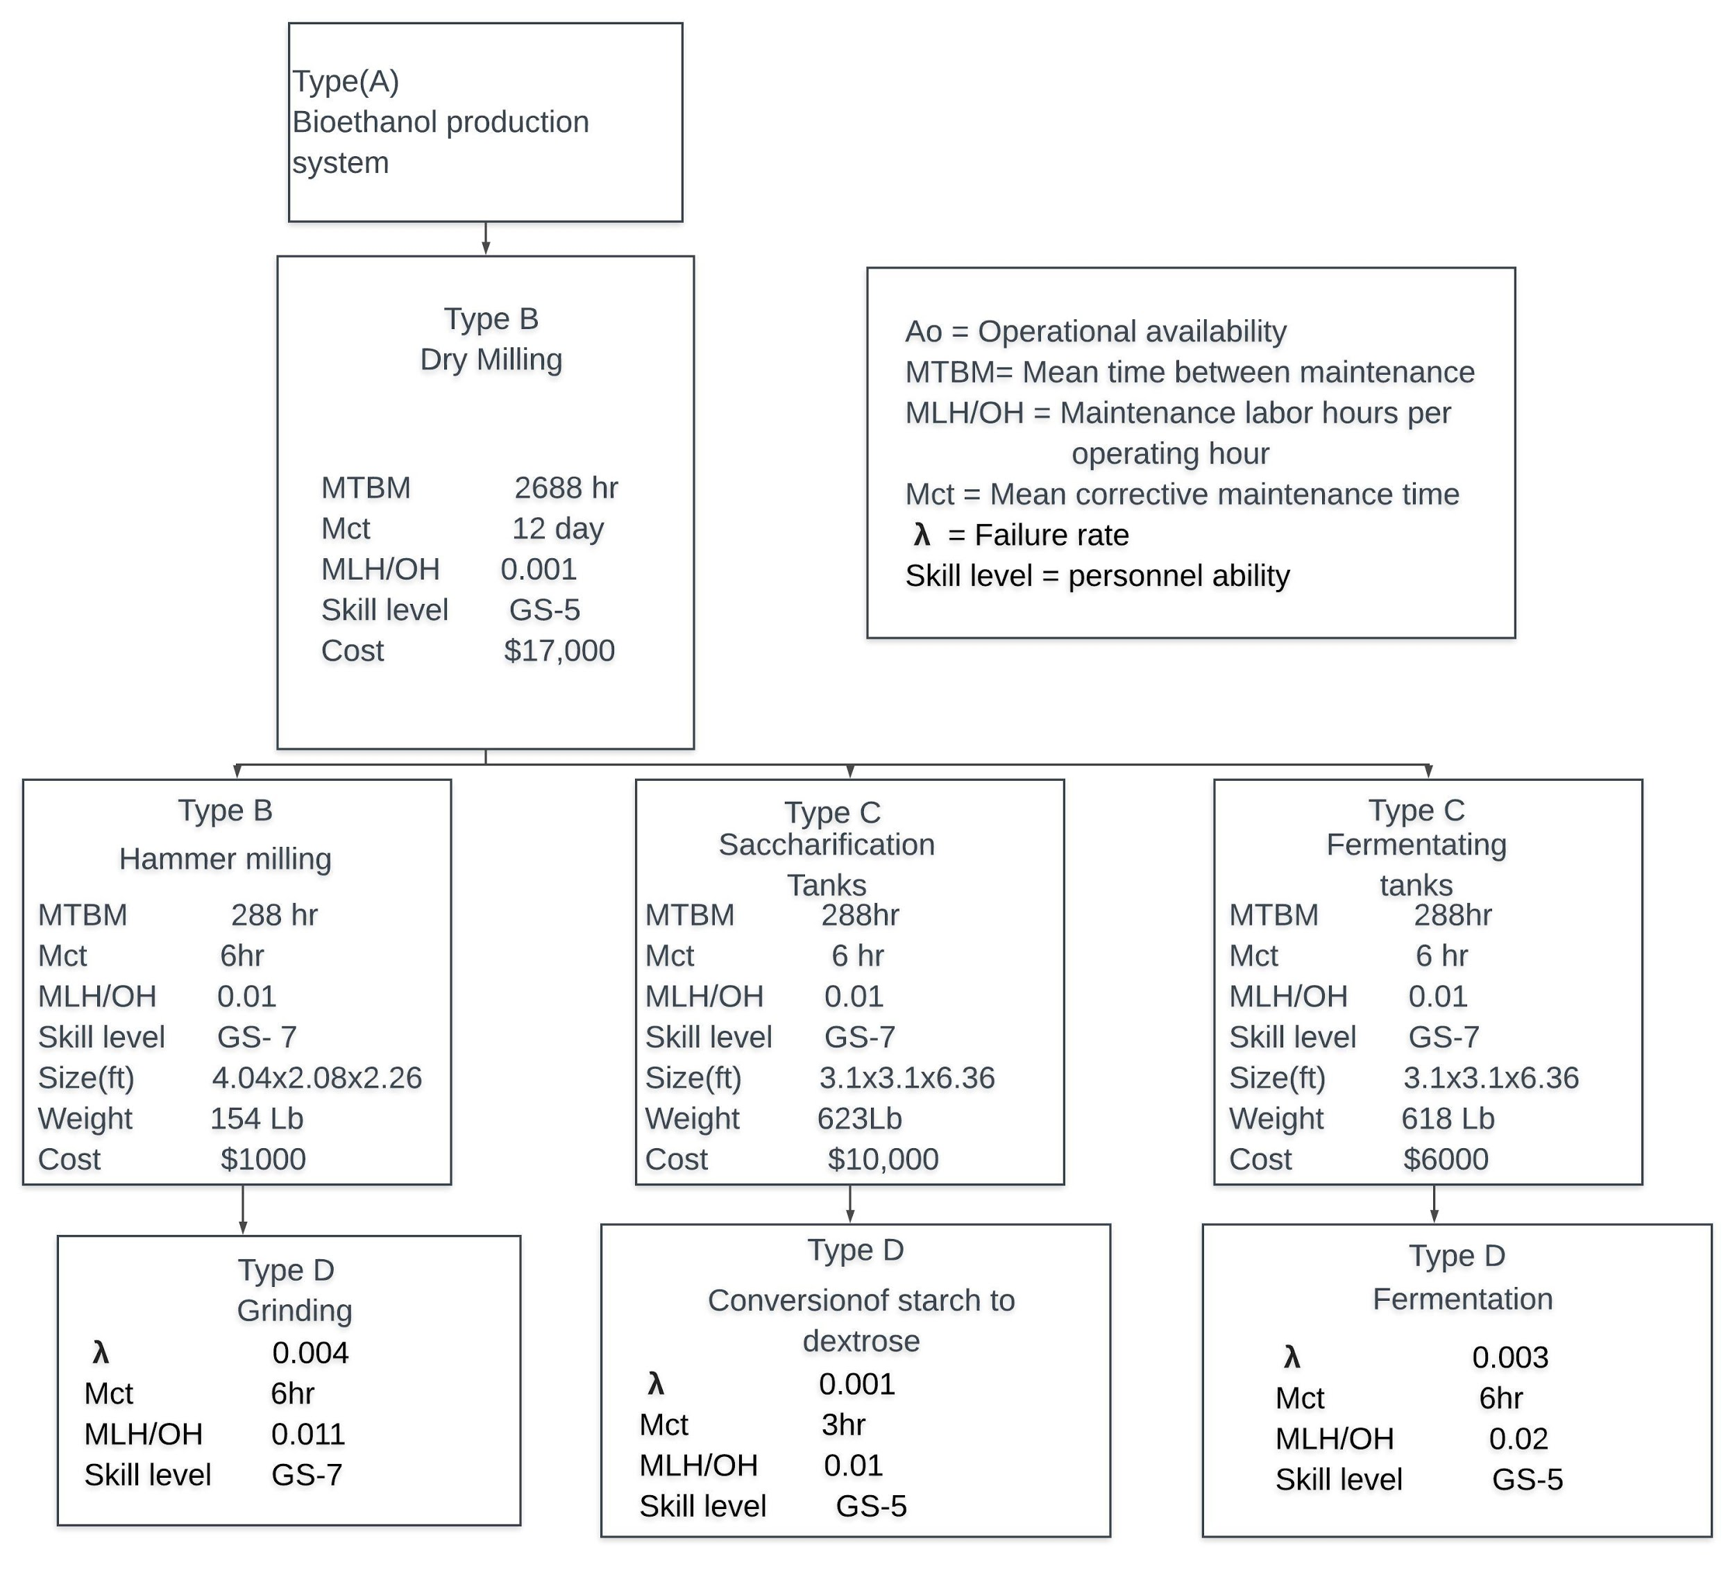

**Figure 1: Specifications**

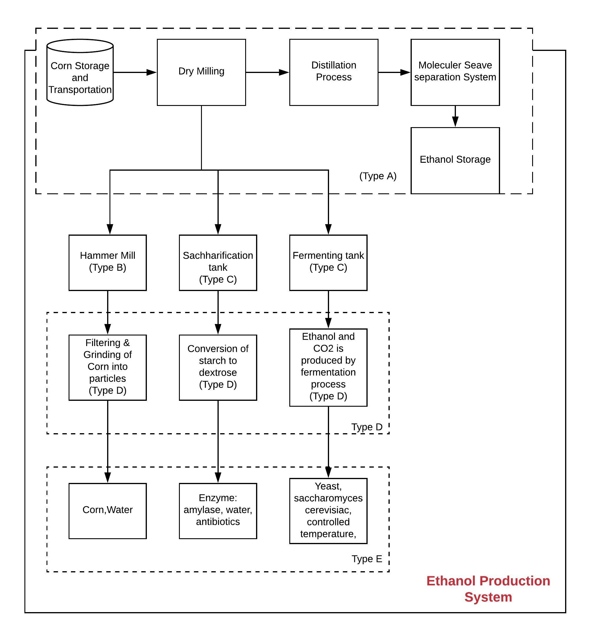

**Figure 2L Documentation Tree**

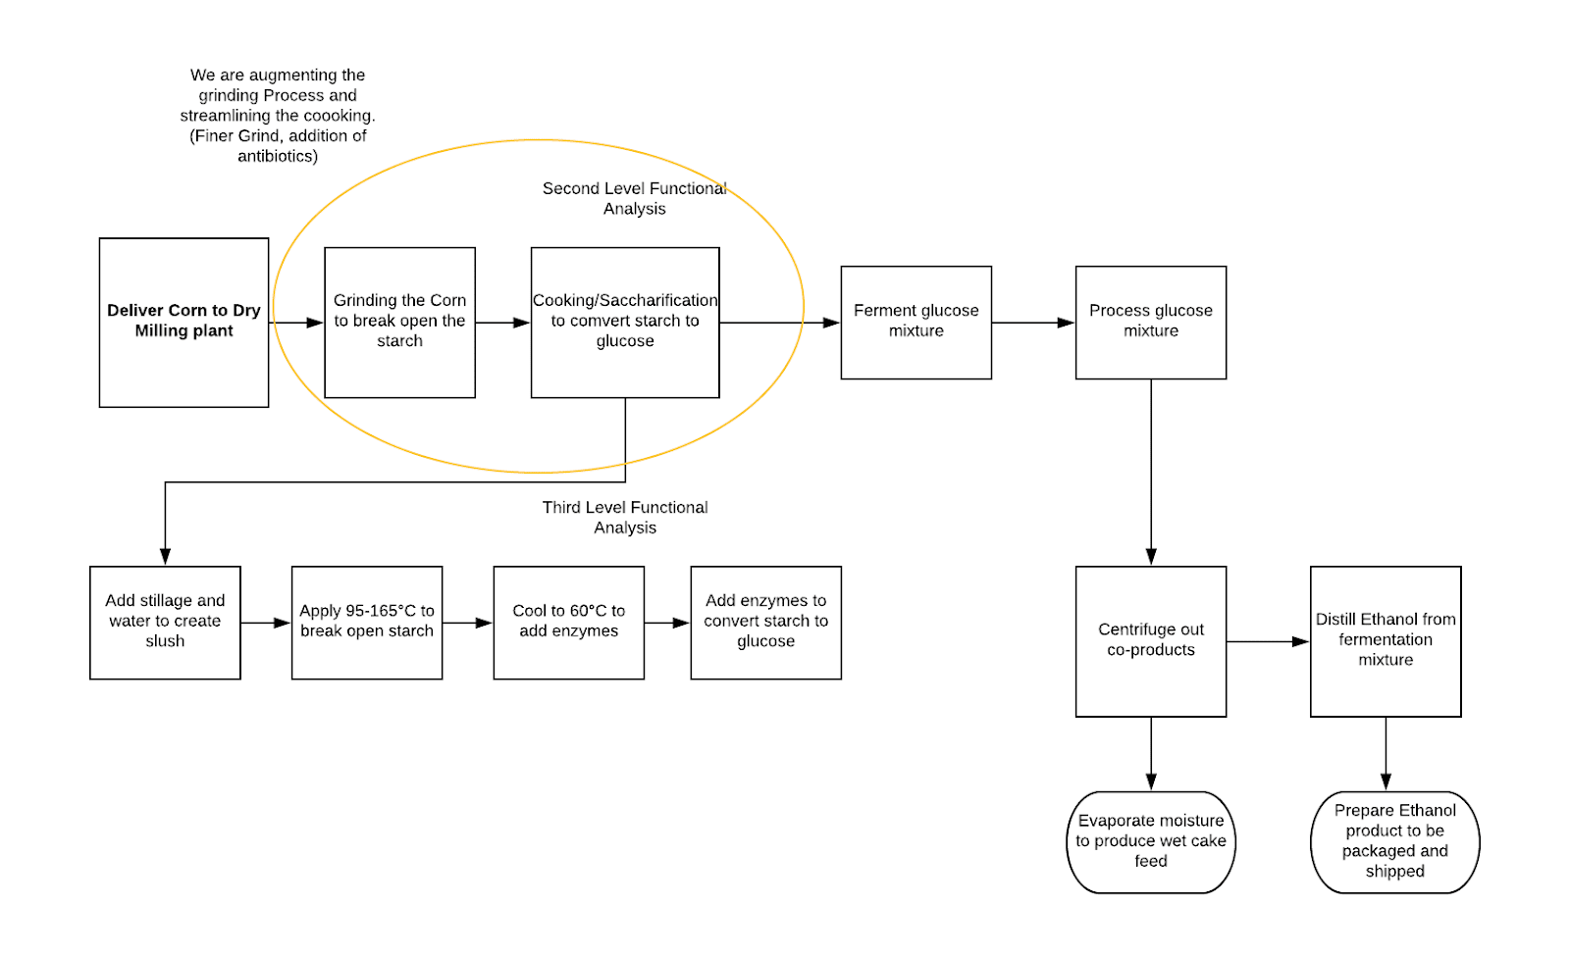

Figure 3: Dry Milling Functional Analysis Diagram